**CMPE-297**

Special Topics

Final Project Report



**Submitted to**

Prof Chandrasekar Vuppalapati

**Date of Submission**

12/01/2017

**Submitted by:**

Alekhya Avadhanula

Mounika Mikkilineni

Pooja Shah

Shanmuga Priya

Sneha Kasetty Sudarshan

**ABSTRACT** **3**

**1. Introduction** **4**

**2. Requirements** **5**

Hardware Requirements 5

Software Requirements 5

**3. Mobile UI Design Principles** **6**

**4. High Level Architecture Design** **7**

4.1 High Level architecture overview 7

4.2 Architecture Diagram 8

5.1 Hardware Components 9

5.1.1 Raspberry Pi3 9

5.2 Software Components 15

5.2.1 Accessing PiCamera 15

5.2.2 Image Classification Using Deep Learning 16

5.2.3 Face Recognition using Machine Learning 16

**6. Workflow** **22**

6.1 Workflow Diagram of iLock App 22

6.2 User Interface 23

**7. Mobile & Cloud Technologies Used & Descriptions** **30**

7.1 Mobile Technologies 30

7.2 Cloud Technologies 31

**8. Interfaces** **32**

**9. Client Side Design** **33**

9.1 Use Case Design 33

9.2 Sequence Diagram 35

9.3 Storyboard 36

**10. Testing** **36**

**11. Automation** **37**

**12. Design Patterns Used** **37**

12.1 Model View Controller 37

12.2.Target Action Design Pattern 38

12.3 Delegate Pattern 38

12.4 Adapter Design Pattern 38

12.5 The Facade Design Pattern 38

**13. Profiling** **38**

13.1 Development Plan 38

**14. References** **39**

# **ABSTRACT**

This project discusses about various frameworks and technologies and that can be applied to a smart door system for automated door locking and unlocking in a house through an iOS application. This system caters the home security system needs for everyone but, especially for visually impaired people. A visually impaired person faces a lot of challenges than an average person when it comes to safety because voice is their primary source of identifying people. Therefore, our iOS application aims at providing a unified solution which will aid everyone in securing their homes. The proposed system comprises of a camera, mounted on Raspberry Pi, fixed at the door to capture the image of the person at the door and send it to the cloud where, machine learning algorithms are used for facial recognition. Once the face is recognized, the user can decide whether to open the door or not through voice commands or a simple button click.

# **1. Introduction**

Home security systems play an important role in ensuring the safety of individuals. It is observed that the crime rate has been increasing by a marginal percentage as we pass through the years. This raises a major concern about personal safety among all the citizens. It was also observed a visually impaired person is at a higher risk than an average person when it comes to burglaries, home intrusions and invasions. Although, there has been a major advancement in home automation, smartphone technology and wireless communication, the need for an ideal home security system is still prevalent.

The most frequent challenge visually impaired people face is of not able to recognize people. It is a basic security concern to check the identity of a person before they are allowed to enter into the house. Most of the advanced security systems involve monitoring the premises through surveillance cameras at all times which is not ideal for visually impaired people. Even for an average person, it is not feasible to keep monitoring the surveillance camera feed at all times. So, for the convenience, it is necessary to minimize user involvement in scrutinizing and monitoring processes and make the decision making process as quick and simple as possible. Object tracking/recognition, face tracking/recognition, have been evolving rapidly due to the advancement in machine learning. Using this technology, it is possible to distinguish between known people and unknown people by training the system.

In this project, Raspberry Pi kit plays is mounted on the door to capture an image of the person at the door and send it to the iOS device. The images sent are used as training and testing data sets for the machine learning algorithms to identify known contacts and point out unknown contacts. To know who’s at the door, the user can interact with the app through voice commands. The application processes the commands using Alexa Voice Services, Sirikit and immediately triggers the facial recognition algorithm and conveys the name of the person or specifies as unknown. Once the person at the door is identified, it is up to the user whether or not to let that person in and can perform door lock/unlock operations through the application. The Raspberry Pi kit at the door receives these commands and performs the required action.

Since all the devices are placed in distant locations in a home, wireless communication is required for data transfer and communication between them. Either Wifi or Bluetooth technology can be used. For better connectivity and efficiency, in this project Wi-Fi technology is used as the medium of communication between these devices. As all the devices are under the same roof, within the same network, Wi-Fi is a more feasible option for this project.

In the later sections of this report, related solutions to ours have been compared, contrasted and the detailed description of system architecture, requirement, components, use cases, mobile application and its user interface have been explained.

# **2. Requirements**

There are a few prerequisites in order to start development of the system. iLock requires hardware as well as software components. The requirements are listed below:

#### Hardware Requirements

* Raspberry Pi3
* Raspberry Pi Camera
* ServoMotor with a latch
* Alexa Dot

#### Software Requirements

* iOS 11
* XCode 9.0 with Swift 3.0
* Siri Kit
* Home Kit
* Python 3.+
* Flask
* NodeJS
* VNC Viewer
* NMap Tools

# 

# **3. Mobile UI Design Principles**

A good user friendly and easily understandable GUI is very essential when it comes to mobile applications. Since our application is based on iOS platform, design principles described in human interface guidelines by Apple, were considered as a reference. The following are the design principles which were followed while working on GUI for our application:

1. *Aesthetic integrity* - This principle states that the app’s behavior and appearance should match with its functionalities. This means that the user should not be distracted by any forms of obstructions like graphics or games when required to perform a critical task using the application. So, in our application, we have used simple and lucid screens with no distractions.
2. *User control* - In iOS, people are given the authority to control and not the application. An application can suggest an alternative, notify the mistakes or warn the user about the consequences but cannot interfere with the decision making process. In our application, the user is given complete control over all the operations.
3. *Metaphors* - Users can easily relate to the application if digital world objects are metaphors of real life actions. Simple actions like toggle switches, scrollers, tab bars, sliders help the user to interact physically with the application. In our application we have used tab bars and scrollers for the same reason.
4. *Direct manipulation* - The app should facilitate direct manipulation through the actions performed by users on screens. This manipulation should also allow users to the consequences of actions performed through immediate visible results so that, the users will be able to understand the functions of the application and act accordingly.
5. *Consistency* - The text styles, terminologies, interfaces and elements involved in the application should be uniform throughout the application. Using standard conventions, known icons and elements will be favorable for all kinds of audience.
6. *Feedback* - Sending feedback acknowledgements as a response to user actions through sounds, text, animations and so on will help the user get a clarity about the results of performed actions. Understandable feedback through simple interactions will aid in improving the user perception of the application.

# **4. High Level Architecture Design**

### 4.1 High Level architecture overview

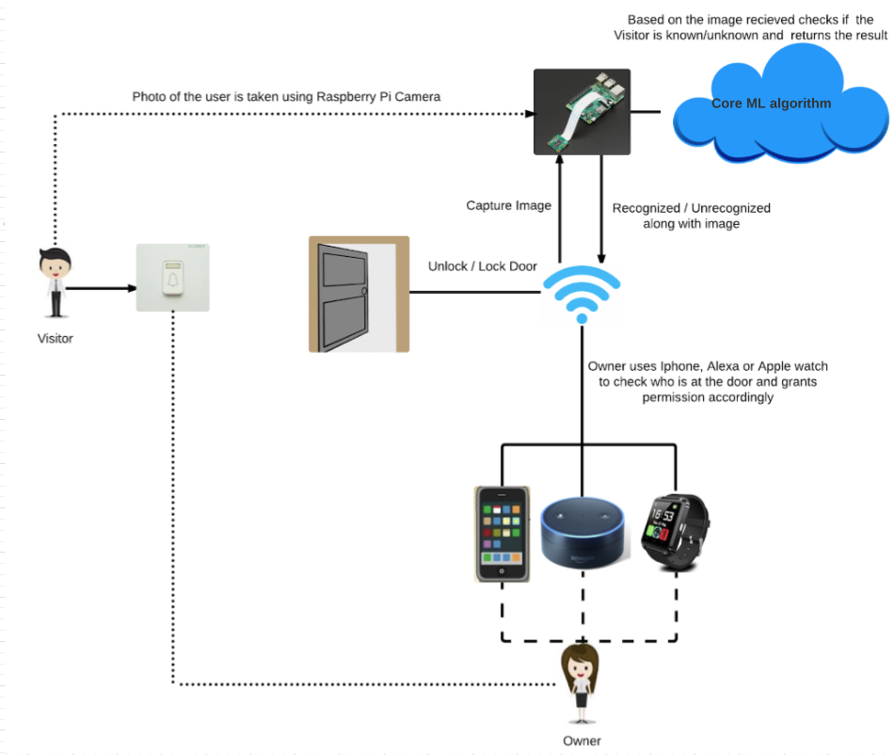

Fig 1. High Level Architecture Overview

All major components including hardware components and technologies used for developing the project is depicted along with information on it how they are connected. The workflow on how the connected devices work is discussed in detail in Chapter 6. Workflow.

### 4.2 Architecture Diagram

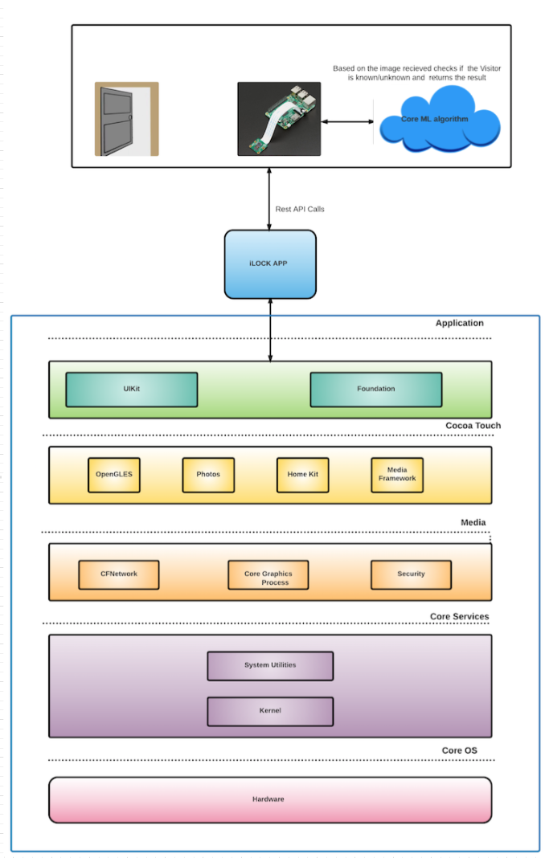

Fig 2. Basic Architecture

The iOS application is a user based application which was developed using Swift 3.0. The “iLock” application uses UI Kit Framework for rendering the foundation and UI. Homekit Media Framework and Photos are required along CFNetwork that takes care of network services along with administering HTTP service requests.

**5. Component Level Design**

iLock system components contains Hardware as well as Software components. Following fig shows the interactions between both the components. When the person rings a bell, owner can access the iOS app to see the person visiting. The app will show the image to owner along with the result of recognized/unrecognized person’s name from Machine Learning engine. and activate either the manual buttons or Alexa/Siri to open the door. Raspberry Pi acts as the main hardware module and central engine which holds the REST endpoints.

Following are the detailed description of components and the initial setup for iLock System.

### 5.1 Hardware Components

#### 5.1.1 Raspberry Pi3

Raspberry Pi3 is built on ARMv8 Quad core 64 bit processor with 1.2GHz, 1GB RAM. It comes with built-in wireless and bluetooth (Bluetooth Low Energy support) connectivity, 4 USB ports, 40 GPIO pins, Full HDMI port, camera port and so on.

|  |  |
| --- | --- |
| Fig 3. Raspberry Pie3 40 Pins | Fig 4. Raspberry Pie3 Motherboard |
|  |  |

Steps to configure Raspberry Pi3 for iLock

1. Download and install Raspbian operating system on 32GB SD card from <https://www.raspberrypi.org/downloads/raspbian/>
2. Insert the SD Card in SD Slot of the raspberry pi3.
3. Plugin the keyboard, mouse and monitor and connect the power cable.
4. Raspbian operating system will boot.
5. Connect the ethernet cable to LAN network.
6. Enable the SSH from settings.
7. Once the module is in LAN network, you can SSH into the Raspberry Pi3.
8. You can then connect to the WiFi (optional step). Steps to connect Raspberry Pi to Wi-Fi:

* Connect the Raspberry Pi to using the Ethernet Cable.
* Open terminal and type ipconfig command
* Get the IP address of the device that is connected to the Ethernet Adapter
* Run NMap to obtain the IP address of the Raspberry.
* Open VNC viewer and connect to Raspberry Pi and activate the Wifi
* Open terminal in Raspberry Pi via VNC viewer and run ifconfig and get the wlan’s IP address.

1. You are ready to use this tiny device on your LAN network.

Once the last step is successfully implemented, the Raspberry PI can be accessed from any computer by connecting with the known wlan address. You can then use following commands to get your Raspbian operating system updated.

sudo apt-get update  
sudo apt-get upgrade  
sudo reboot

5.1.2. Raspberry Pi3 Camera

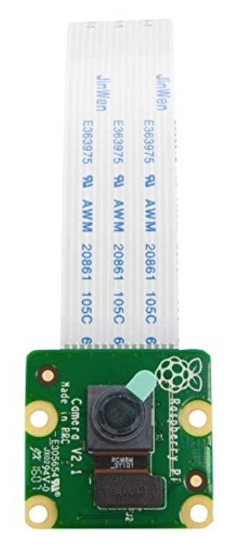

Fig 5. Camera Module

As shown in fig, we used second generation Raspberry Pi Camera Module with Fixed Focus Lens. It is capable of 8MP and 1080p resolution in order to capture a clear image of the visitor. We can insert this camera module in the Raspberry Pi by just sliding the white portion into the camera port. The 8MP camera will help to take high resolution pictures. The images once obtained will be stored in a local folder which will be accessed by the script running the ML algorithm. VNC viewer and SSH is used for writing scripts in the Raspberry Pi3.

Enabling Camera module in Raspberry Pi:

* Go to preferences in raspberry pi and select the devices option and enable camera if using VNC viewer else do the following:

In Raspberry Pi terminal run the following command:

sudo raspi-config

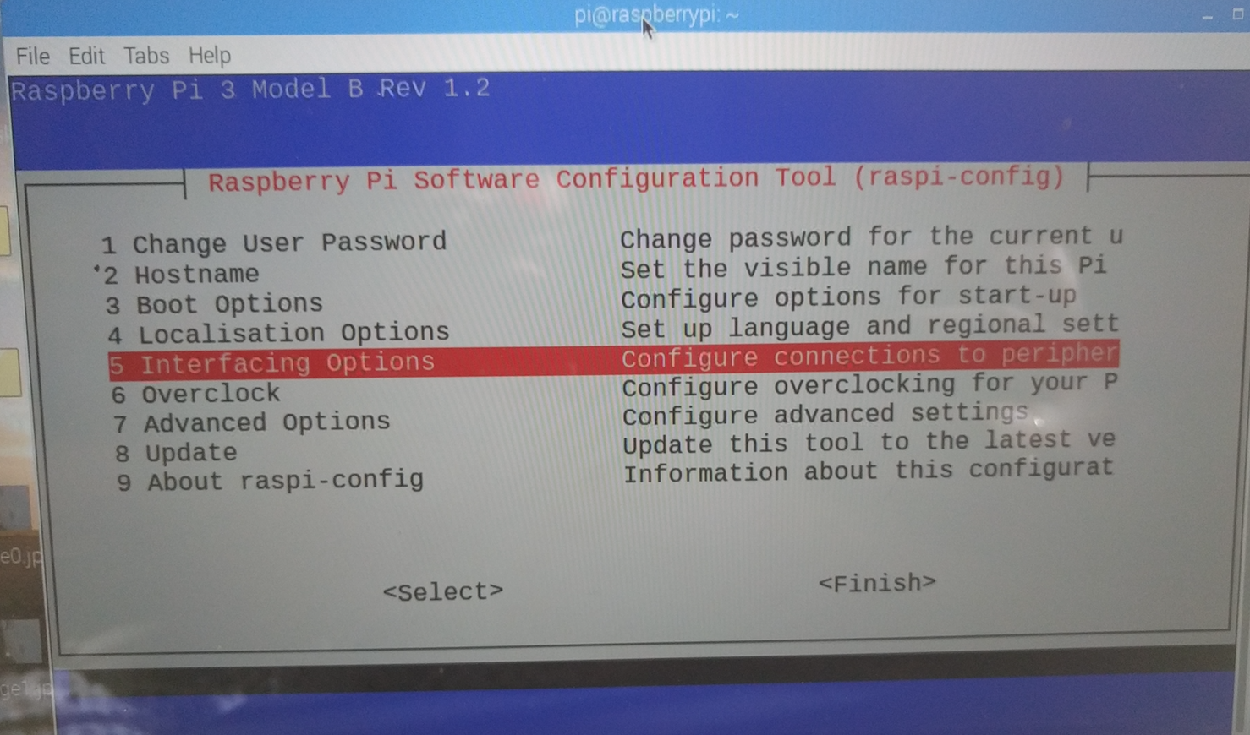

Fig 6.Select Interfacing Options

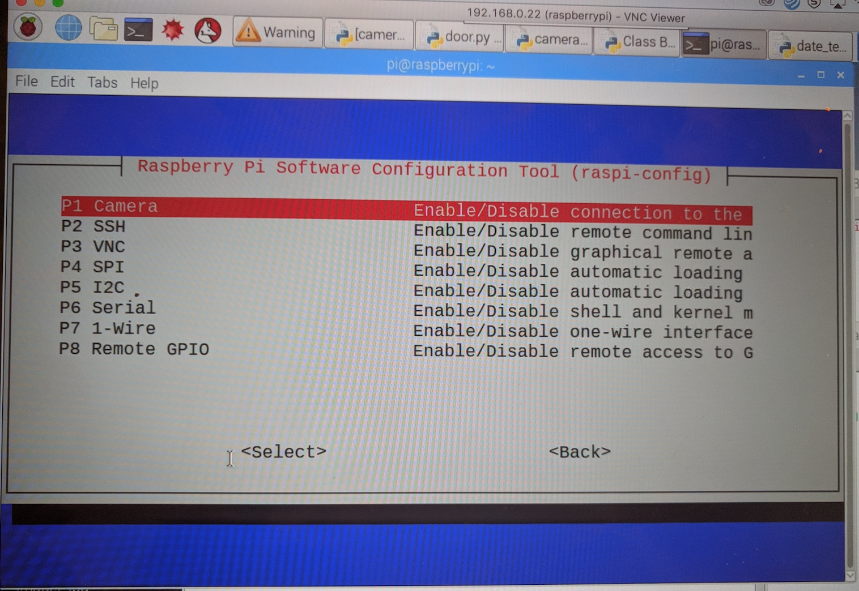

Fig 7. Select P1 Camera option

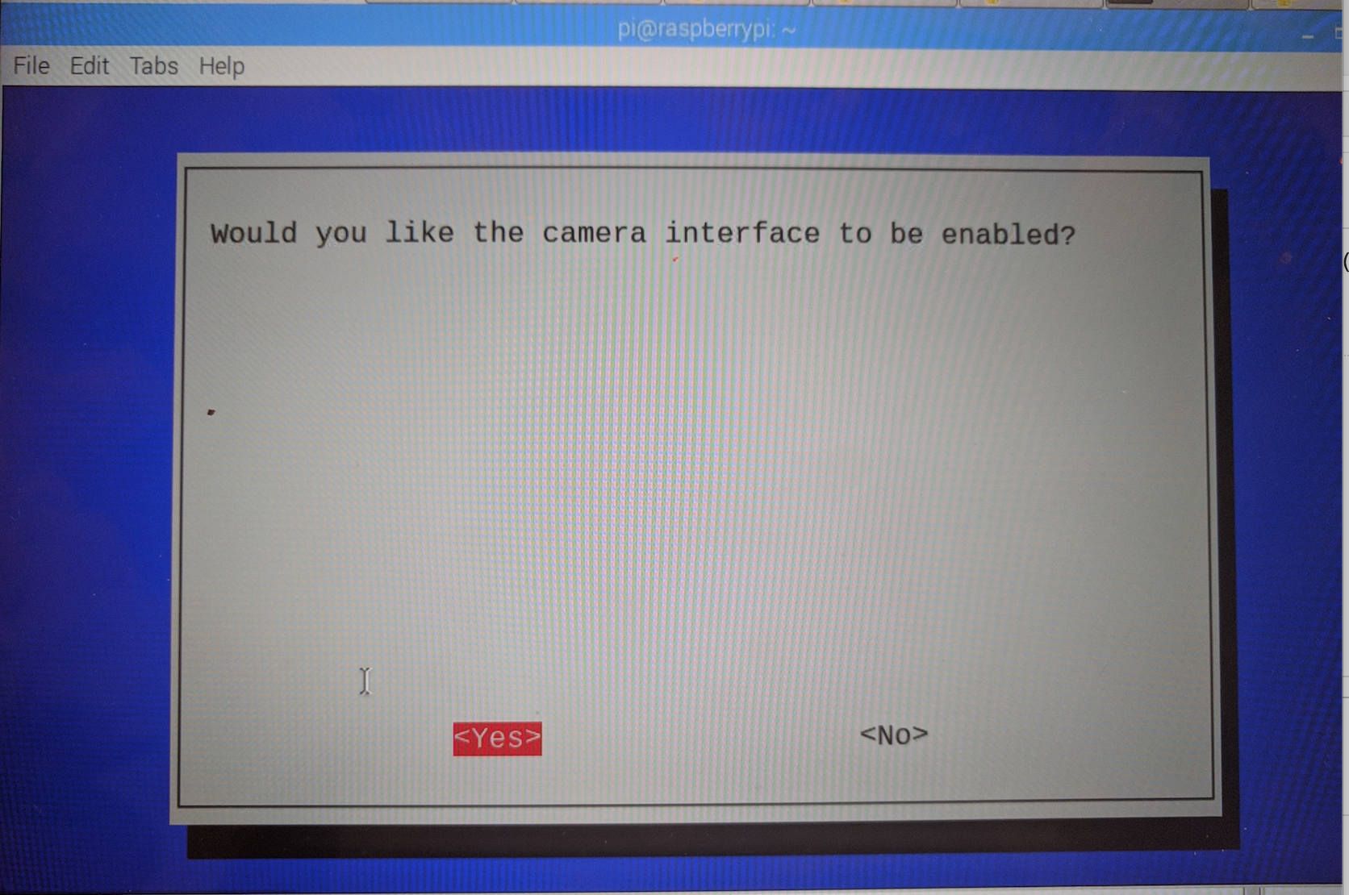

Fig 8. Click on Yes button

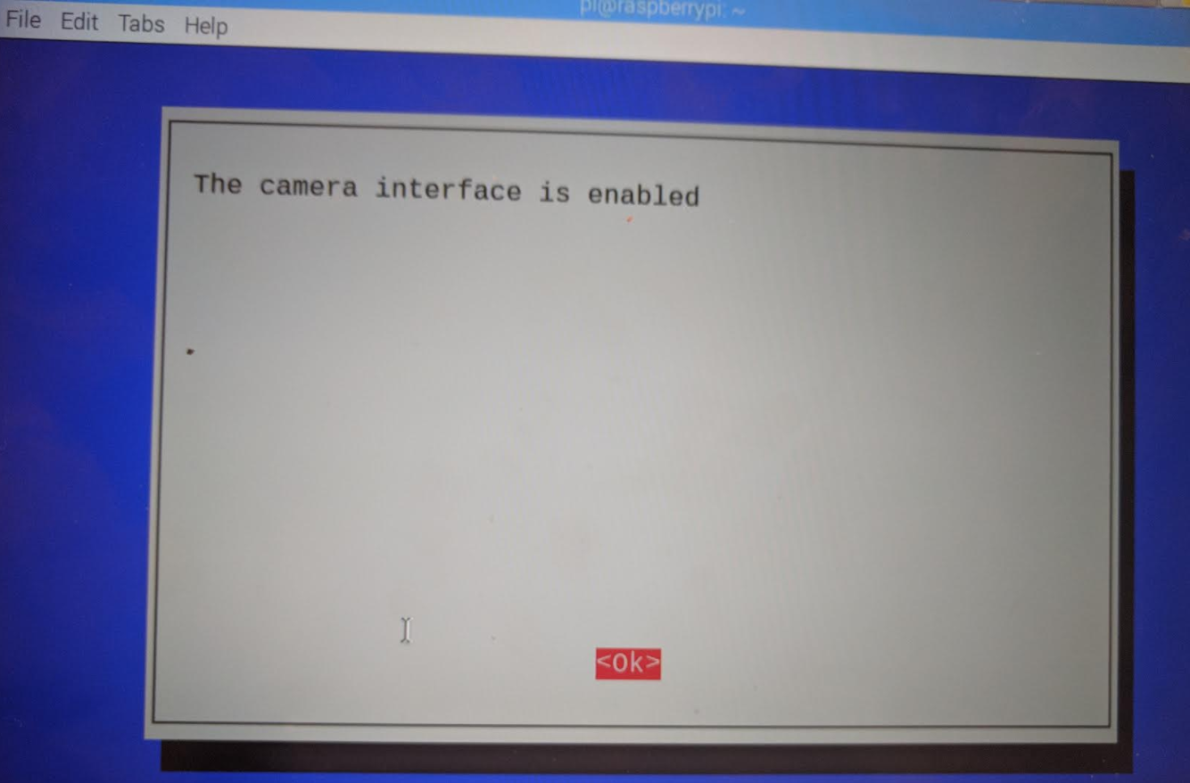

Fig 9. Success message after camera is enabled,click on OK

Once these steps are implemented, Python based script is implemented such that once the camera script is triggered a set of five images are obtained at an interval of 5 seconds. For the camera module to be triggered from outside flask is implemented such that, the camera.py script can be called using the REST API.

The flow of the Raspberry PI camera is as follows:

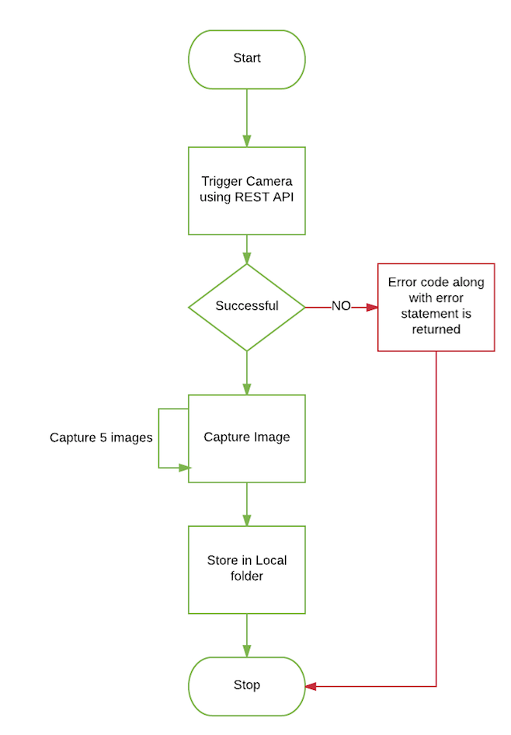

Fig 10. Workflow of Raspberry Pi3 Camera Module

5.1.3. Servo Motor

A servomotor as shown in the below figure is a device with a shaft. Based on the coded signal received by the servomotor it can rotate its shaft. The doors latch is attached to the shaft so that it can lock and unlock the door. The servoMotor needs to be connected to the right pins of the Raspberry Pi, to enable the motor to rotate .

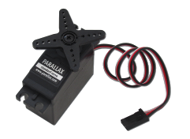

Fig 11. Motor

5.1.4 Alexa

Alexa dot is configured with iOS Homekit to use the Alexa voice commands to lock and unlock the door.

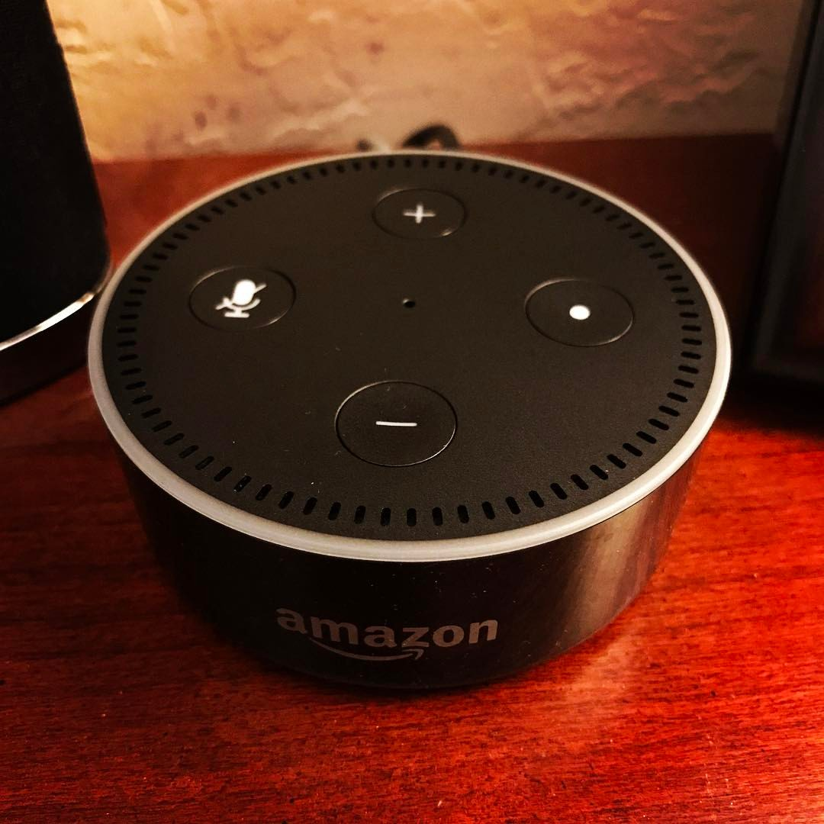

Fig 12. Alexa Dot

### 5.2 Software Components

#### 5.2.1 Accessing PiCamera

In this project, Raspberry Pi3 camera is used to capture images. Following diagram shows the code snippet of Camera module execution.

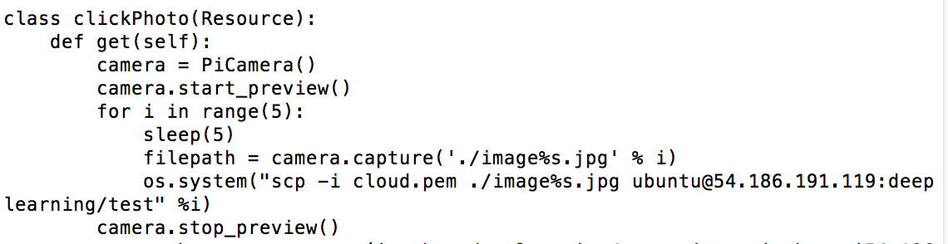

#### 5.2.2 Image Classification Using Deep Learning

Deep learning is an approach used for solving image classification. It allows us to teach the computer how and what different objects or things look like and it helps to identify those objects. Image classification assumes that the image has one object and classifies it into one of the trained categories.

We have used existing dlib trained model for face recognition. The model outputs face encoding numbers. The input to the model is an image, the model then compares the face encoding from different image and tells if the image matches with anyone.

The name of the models which we have used in our app are

1. Dlib-face_recognition_resnet_model_v1.dat
2. Shape_predictor_68_face_landmarks.dat

#### 5.2.3 Face Recognition using Machine Learning

Face Recognition component is an important component of iLock System. Once the Image is captured from Raspberry Pi camera, images are then passed to the python based machine learning engine. To detect the face of a visitor, this engine stores the database of images and compares with the images that are already stored to find the better match. If a match is found against some image, the confidence index is displayed for the particular image. Machine Learning (ML) is used for this process in order to recognize the unknown images based on the history of images input. Even though the inputs are not given from user, system should recommend the face appearance and learn from experience by using the classes and performance. Mainly classifiers are written in order to recognize the patterns. Once the pattern is recognized, the automatic labelling helps to match with unlabelled dataset.

**Steps for Detecting Faces**

1. Detect faces from image.
2. Predicting face poses or landmarks for face identified in above step.
3. Calculate the face encodings from face.
4. Compare the face encodings from test images.

Detailed flow of an algorithm is shown in the fig .

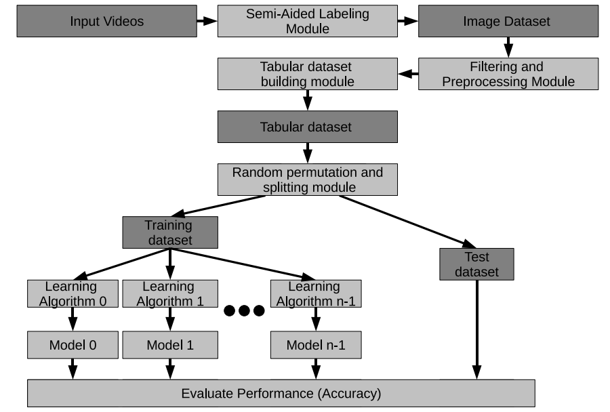

Fig 13. Block Diagram of Face Recognition ML

As shown in above fig, the image dataset is filtered and preprocessed. In this process, we perform the actions using the pose detection and alignment of the image. In Later step, the images are converted in csv file and generates embeddings for each image. Dataset is divided into train and test dataset.

**Setting up the Face Recognition on RaspberryPi**

1. Increase the swapfile size

sudo nano /etc/dphys-swapfile

Change the value of CONF_SWAPSIZE from 100 -> 1024

Restart the swapfile

sudo /etc/init.d/dphys-swapfile stop

sudo /etc/init.d/dphys-swapfile start

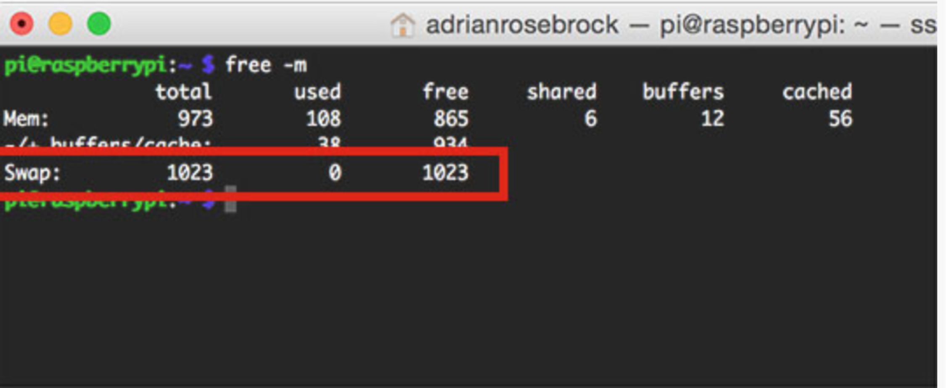

Fig 14. Raspberry Pi Configuration

1. Install cmake 3.9.2

You can use following commands to install cmake successfully

wget http://files1.directadmin.com/services/custombuild/cmake-3.9.2.tar.gz

tar xzf cmake-3.9.2.tar.gz cmake-3.9.2/

cd cmake-3.9.2/

./configure

make

sudo make install

1. Install dlib

pip3 install numpy

pip3 install scipy

pip3 install scikit-image

pip3 install dlib

1. Install face recognition

sudo pip3 install face_recognition

Once you setup your raspberry pi, reboot your raspberry pi. Use the script to run the face recognition. It will provide you the result if the image is recognized or not.

5.2.4 HomeBridge Setup

HomeBridge for integrating with Alexa dot and Apple Watch . Homebridge plugin is written to make the call to the Rest API which locks and unlocks the door latch. The code snippet of the plugin is as shown below.

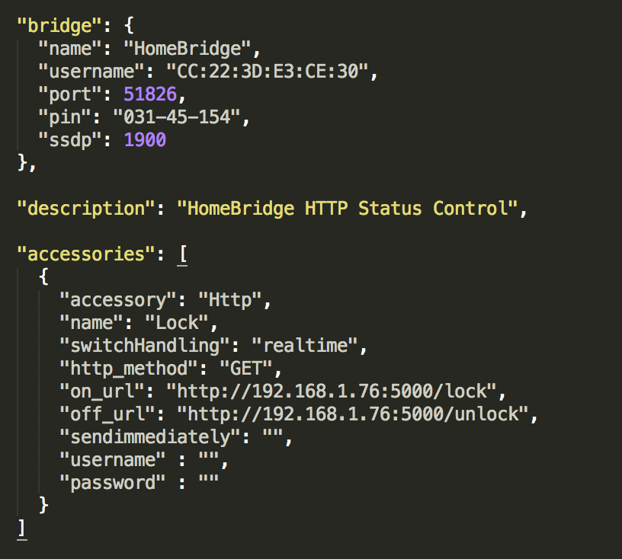

Fig 15. Code Snippet of config.json of Homebridge

5.2.5 Python Script for Rotating the shaft of ServoMotor

Below is the code for starting the server on Raspberry Pi to rotate the servomotor shaft.

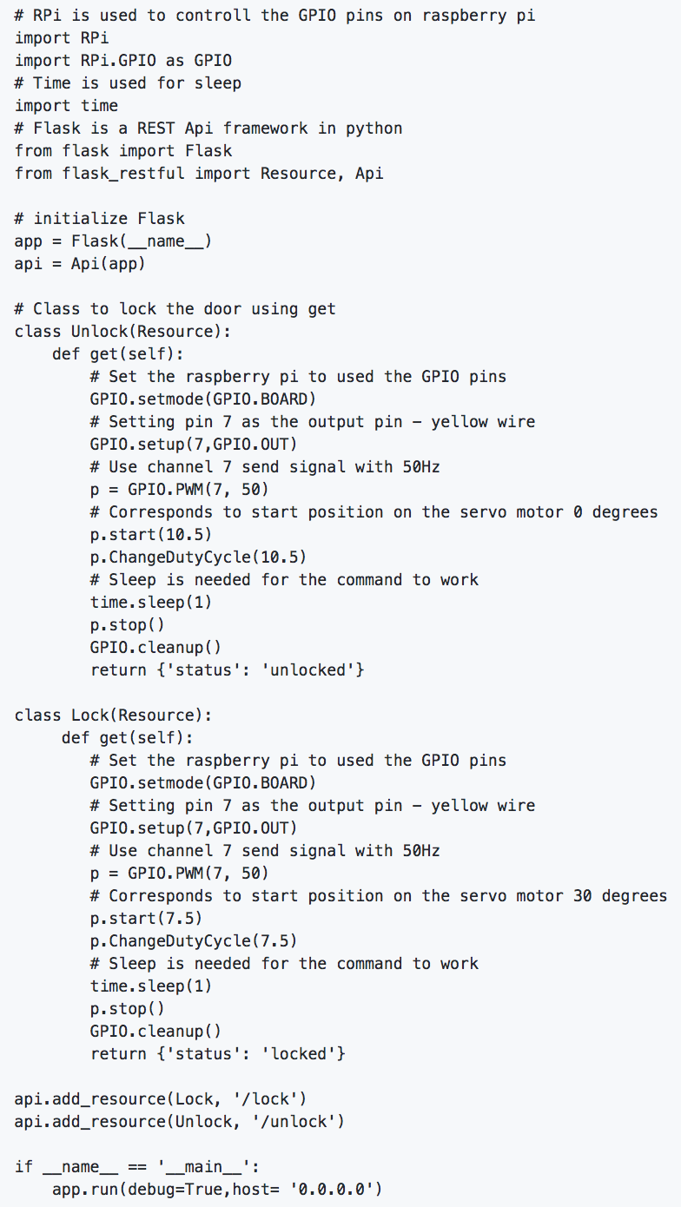

5.3 iLock - iPhone App

5.3.1 Siri

We have integrated iLock App with SiriKit. Now, we can give voice commands to Siri asking it to ‘open the door’ or ‘close the door’, which will unlock the door and lock the door respectively. The commands work by calling the server on the raspberry pi3 with the REST APIs. We have used new Intents extension and activated Siri with the SiriKit. Initially Workout domain was used to check if that can help trigger actions with Siri, considering our app to be a workout app and that was successful. Then we added more vocabulary like: ‘open the door’ and ‘close the door’ to the app, to see if that can trigger the server with REST APIs. And we were successful in integrating our app with Siri. The code for intents extension is as shown below.

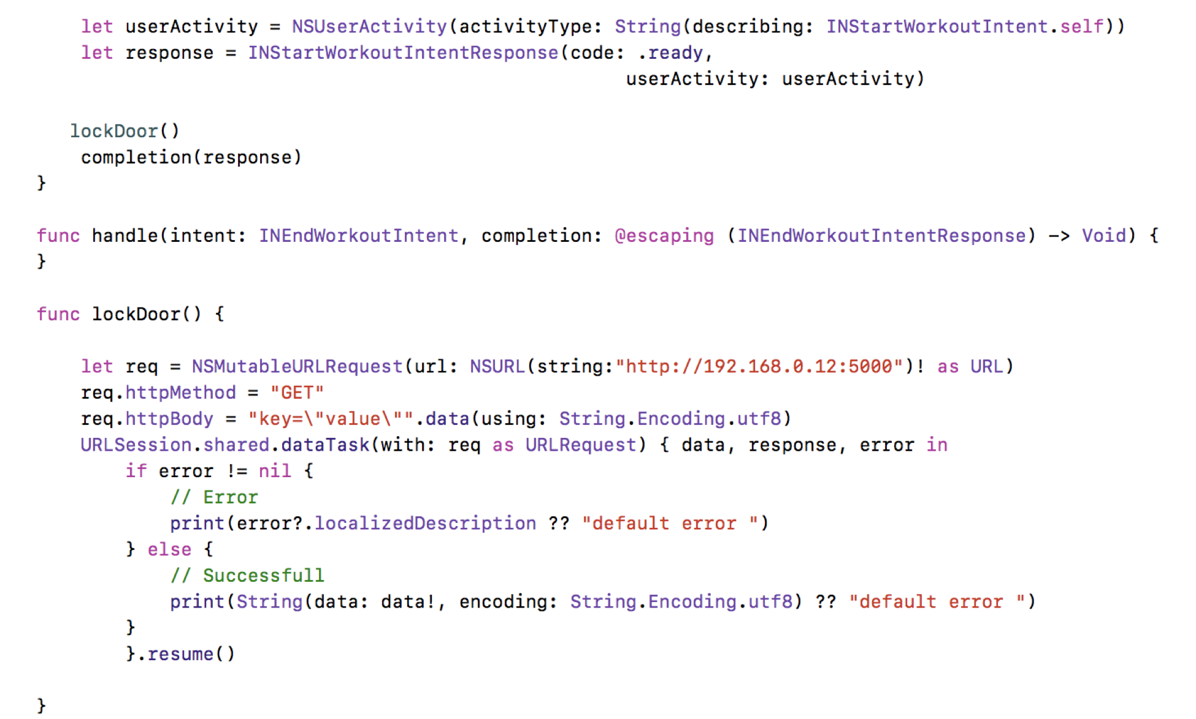

Above code snippet showing the function which hits the server when siri voice commands are given.

# **6. Workflow**

### 6.1 Workflow Diagram of iLock App

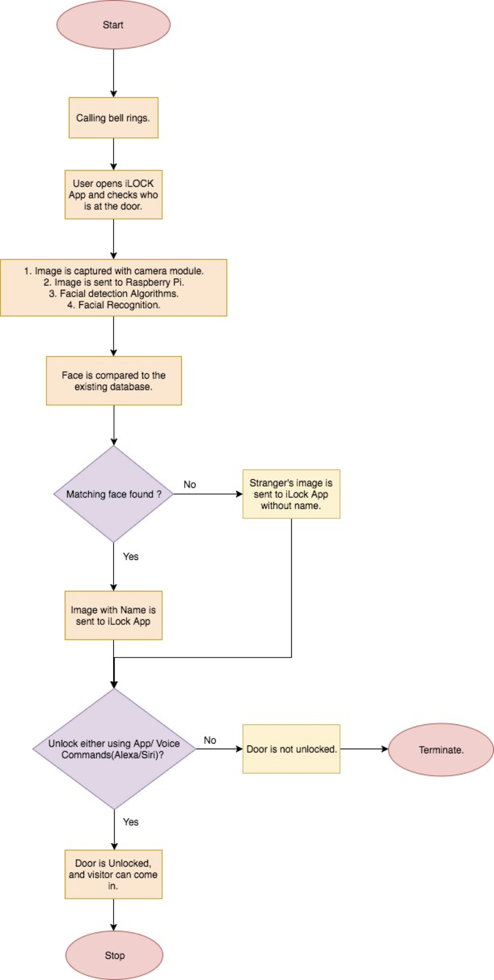

Fig 16. Workflow of the iLock App

In the above figure, the sequence of the workflow is shown. The sequence of actions in the foreground as well as background are discussed below.

1. Visitor comes home and rings the bell.
2. Homeowner will open the iLock App and checks who is at the door.
3. A server on Raspberry pi3 keeps running, where it holds the logic for accessing camera, sending image to face recognition algorithm and locking/unlocking the door, as discussed in detail in the above sections.
4. In the background, when the homeowner clicks ‘who’s at the door?’, a REST API is triggered and sent to the server, where it opens camera and clicks the image of the visitor, checks with the face recognition algorithm and sends it back to the app.
5. Homeowner can see the image with/without name of the visitor in the app, depending on matched/unmatched image in our database.
6. Homeowner can now click ‘unlock the door’ from the app, which unlocks the door.
7. Additionally, homeowner can also give voice commands via Siri / Alexa / Home.
8. Integration with Alexa and Home are added features.

### 6.2 User Interface

The figures in this section depict the screens of the iLock application. This section briefly explains about how the user can interacts and navigates through the application. The user interaction with the application can be easily understood from the screens.

1. The launch screen of the application is a simple screen and appears for a few seconds as soon as the user launches the application.

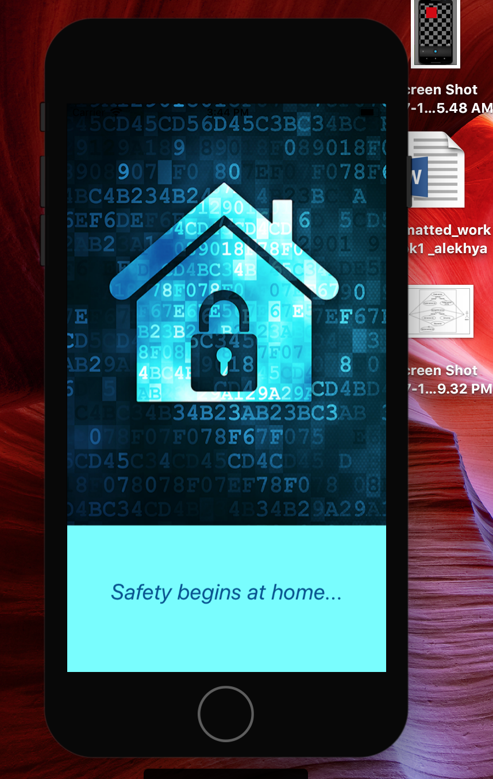

Fig 17. Home Screen of iLock

1. Once the application is launched, the user can see a tab bar with different options like “Home”, “Contacts”, and “History” for navigation. By default, the Home page is chosen as the first screen. In this home page, the user will be able to see who’s at the door and can lock or unlock the door through button clicks from this page. The textview below the image displays the contact name of the person when recognized. If the person is unknown, then the it shows the result unknown.

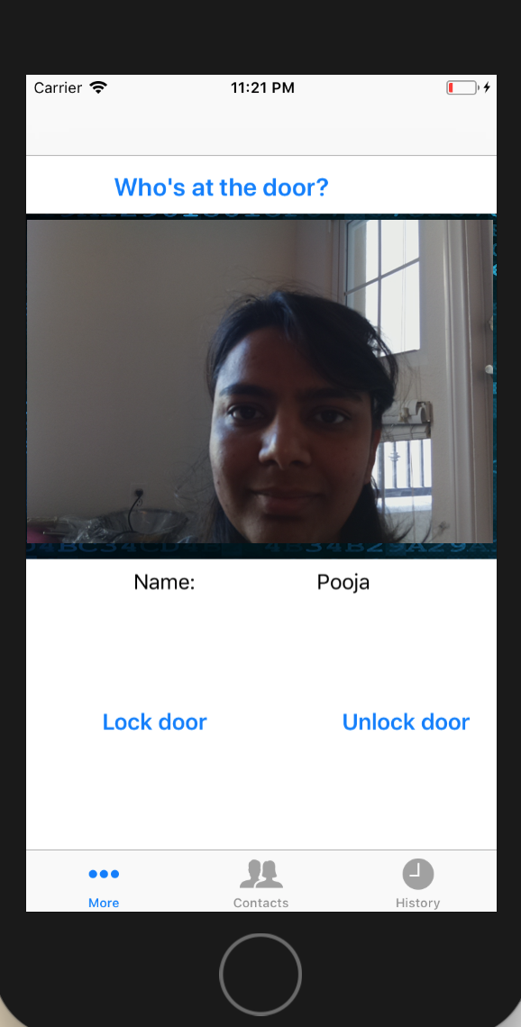

Fig 18. Home Screen of iLock

1. In the History page, the user can check the history of all the recent faces that were recognized using this application. It will also show the image of the visitor and timestamp of when the visitor was at the door.

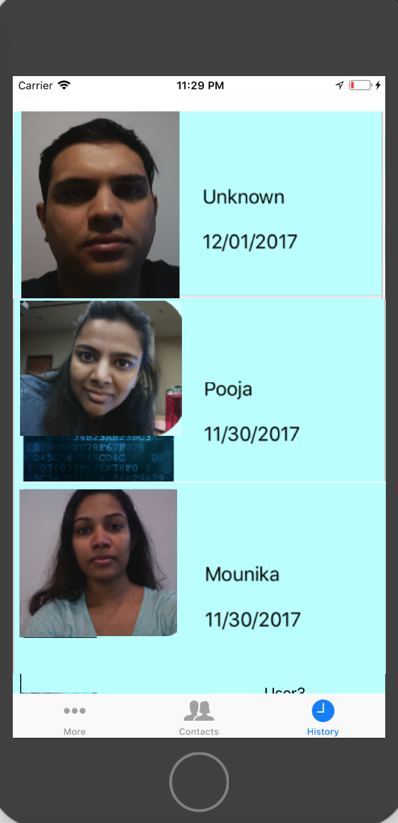

Fig 19. History Screen of iLock

1. In the Contacts page, the list of contacts that were added by the user are shown. This shows the face of the visitor along with their contact name.

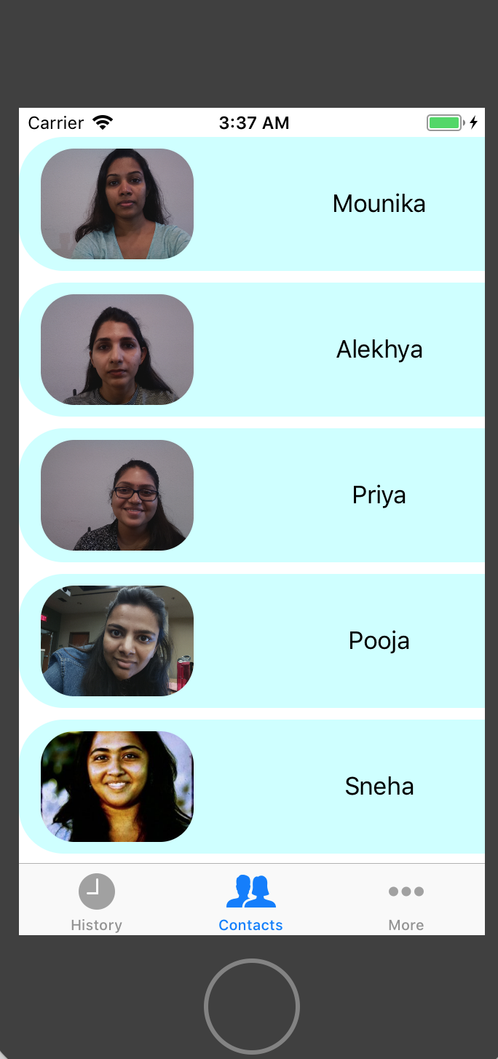

Fig 20. Contact Screen of iLock

1. We can add new contacts to the contact folder which is stored in the cloud. The person image and name is stored.

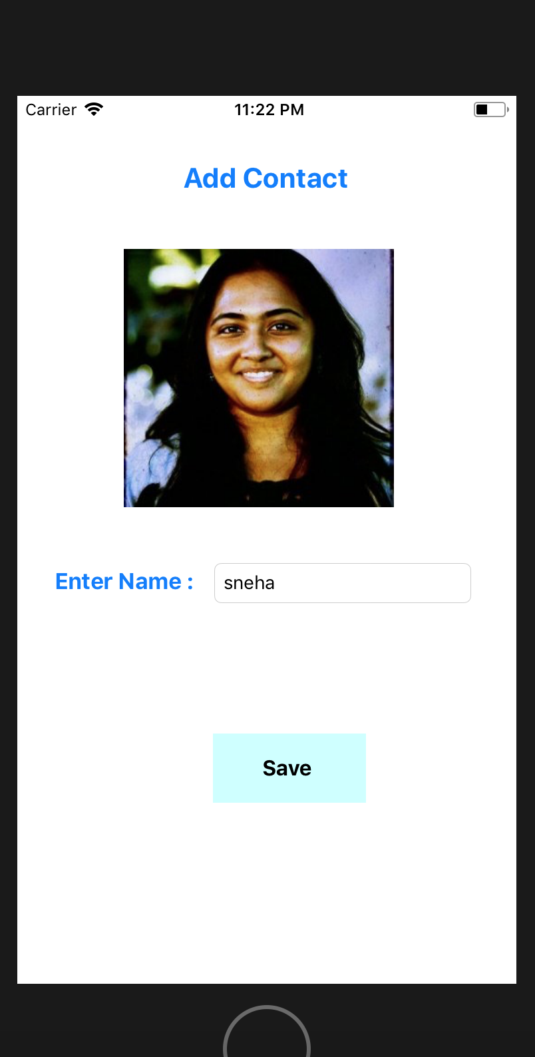

Fig 21: Adding contact to the contacts folder.

1. When there is an unknown person at the door, the name is displayed as unknown. In that case, it will display a button asking whether the user wants to add the person to contacts.

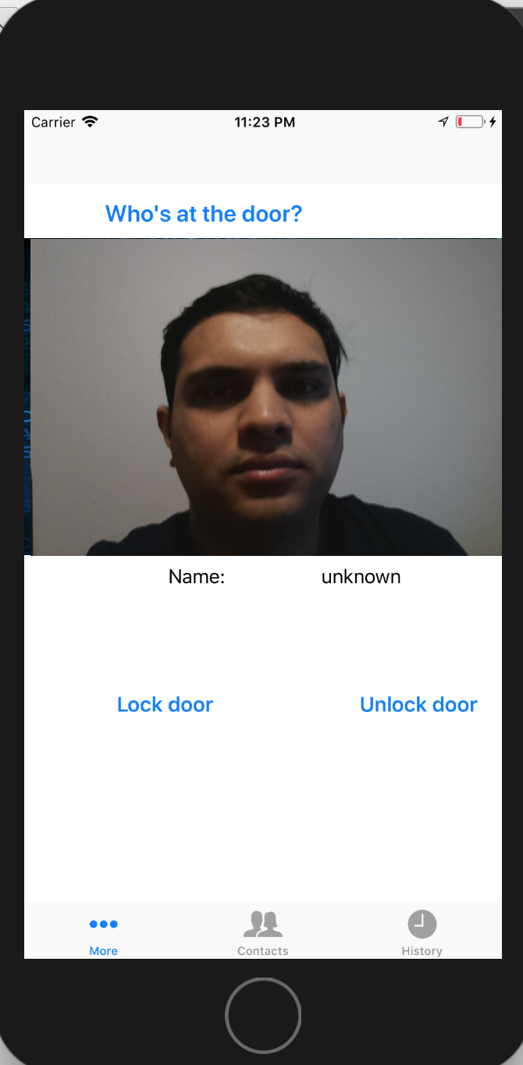

Fig 22. Unknown Person at Screen of iLock

# **7. Mobile & Cloud Technologies Used & Descriptions**

## 7.1 Mobile Technologies

Apple iOS provides variety of development kits for building mobile apps. This project is tested for iOS 11+ devices.

**Development kits**

The project is based on Swift Programming language

* SiriKit

As a part of Voice services, apple provides the SiriKit to recognize the command. Following fig shows how Siri Kit works with the app. As an app developer, we can develop intent extensions which can then handle the response. We

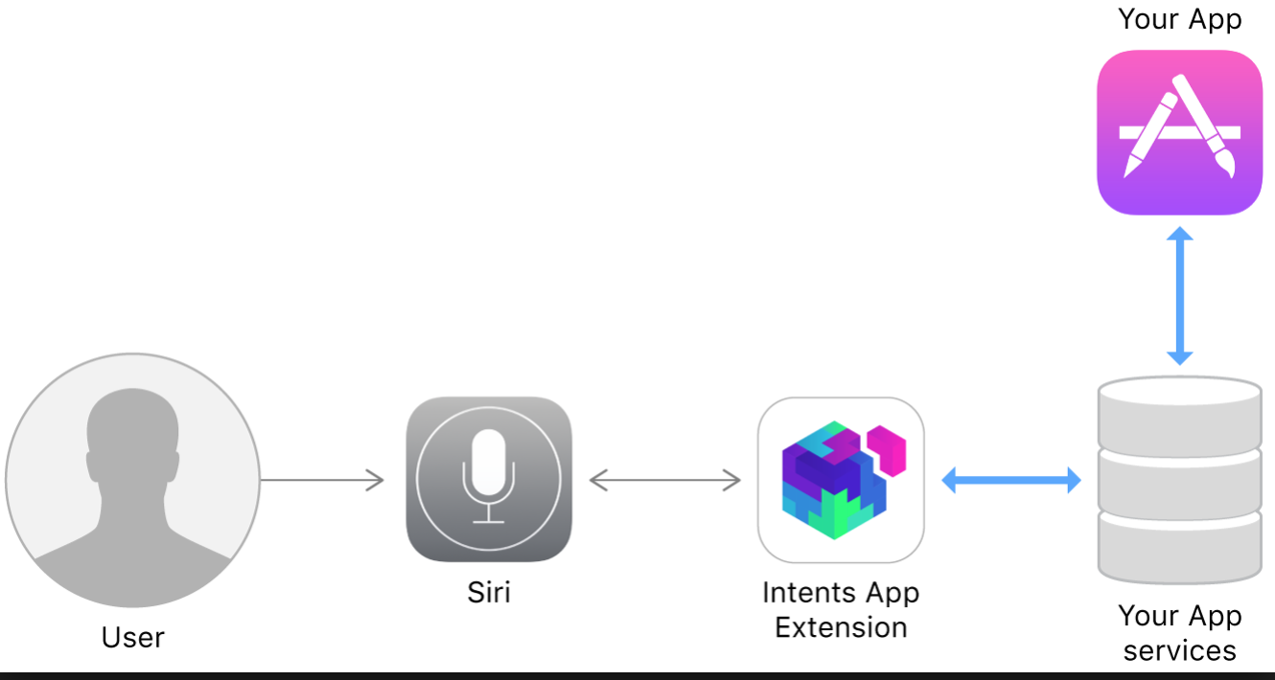

Fig 23. SiriKit Intents

Siri kit Domain Intent follows under following categories :

VoIP calling, Car Play, Restaurant, List and Notes ,Visual Codes, Messaging, Photos, Payments, Ride, Workout and so on but as of now the custom domain is not available for use.

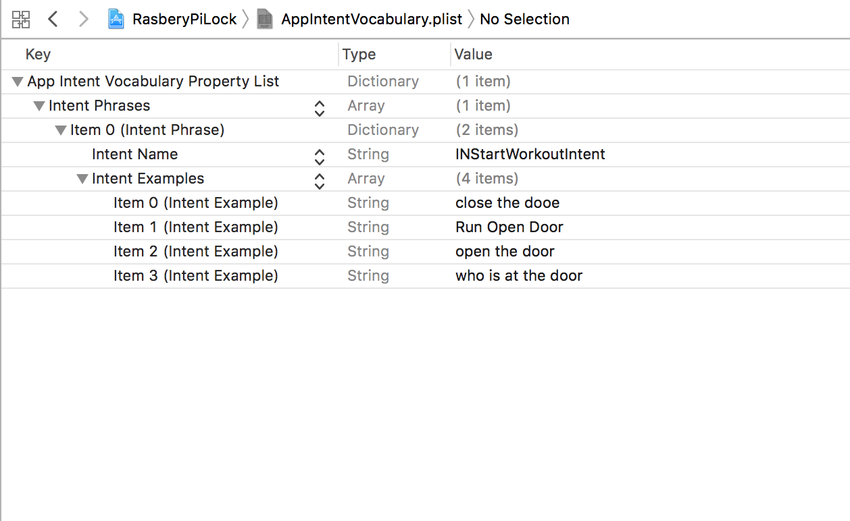

Fig 24. Intent Vocabulary

* AFNetworking : Swift based AFNetworking library is used for networking built on Foundation for connecting to cloud and Raspberry pi3.
* SwiftyJSON : Swift based SwiftyJSON library is used for parsing JSON.
* HomeKit : Swift based HomeKit development kit is used for Home Accessory connection.

## 7.2 Cloud Technologies

In this project we have used AWS EC2 instances as a cloud technology along with the Raspberry Pi standalone hardware.

**Need of Cloud Technology:**

Since Machine learning engine needs powerful hardware configurations for processing, Raspberry Pi like device can not hold the processing. Although once can trick the device to use docker with the image of necessary components for facial recognition, or one can even allow the libraries to run on multiple CPU with parallel execution, the performance of the process is badly affected.

**Specification of EC2 Instance**

The Deep learning API based on 64bit is available to use for free tier. The project uses the following AMI



**Cloud Security** : EC2 instance is strictly used by private and public keys.

7.3 REST API description

iOS 11 App with Swift 3.0

* SiriKit
* HomeKit
* REST APIs

# **8. Interfaces**

Below Figure, shows the interfaces of our prototype. The person at the home door is standing in front of the camera and a hardware module does the processing of the image captures by the camera and sends it to the face detection and face recognition algorithms in cloud. The algorithms process the data, classify and matches the images(test data) with the trained data and gives output. The output is sent back iOS app with/without name depending on the result. So, the interfaces are between Raspberry Pi microprocessor, iOS app and cloud, which we are communicating through REST APIs. To call scripts on cloud, we simply have to ssh. Also, there is Alexa that is configured with Raspberry Pi. Figure 21 shows the interfaces on high level.

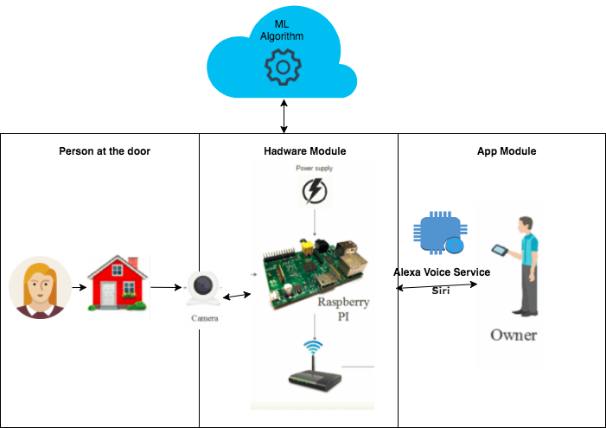

Fig 25. Vertical Interface Implementation

Fig 22 shows the Hardware-software abstraction layer for the current implementation.

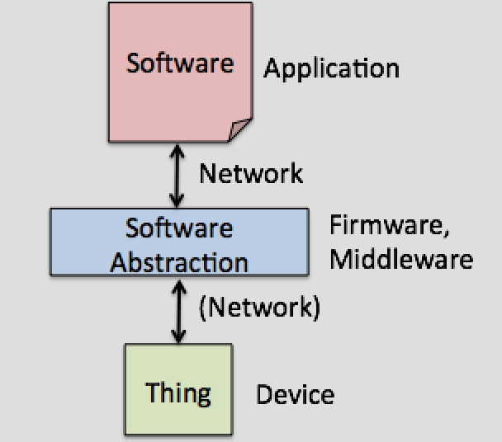

Fig 26. Software Abstraction

# **9. Client Side Design**

## **9.1 Use Case Design**

Below is the use-case design of the Homeowner, which lists all the use-cases of homeowner with the iLock App.

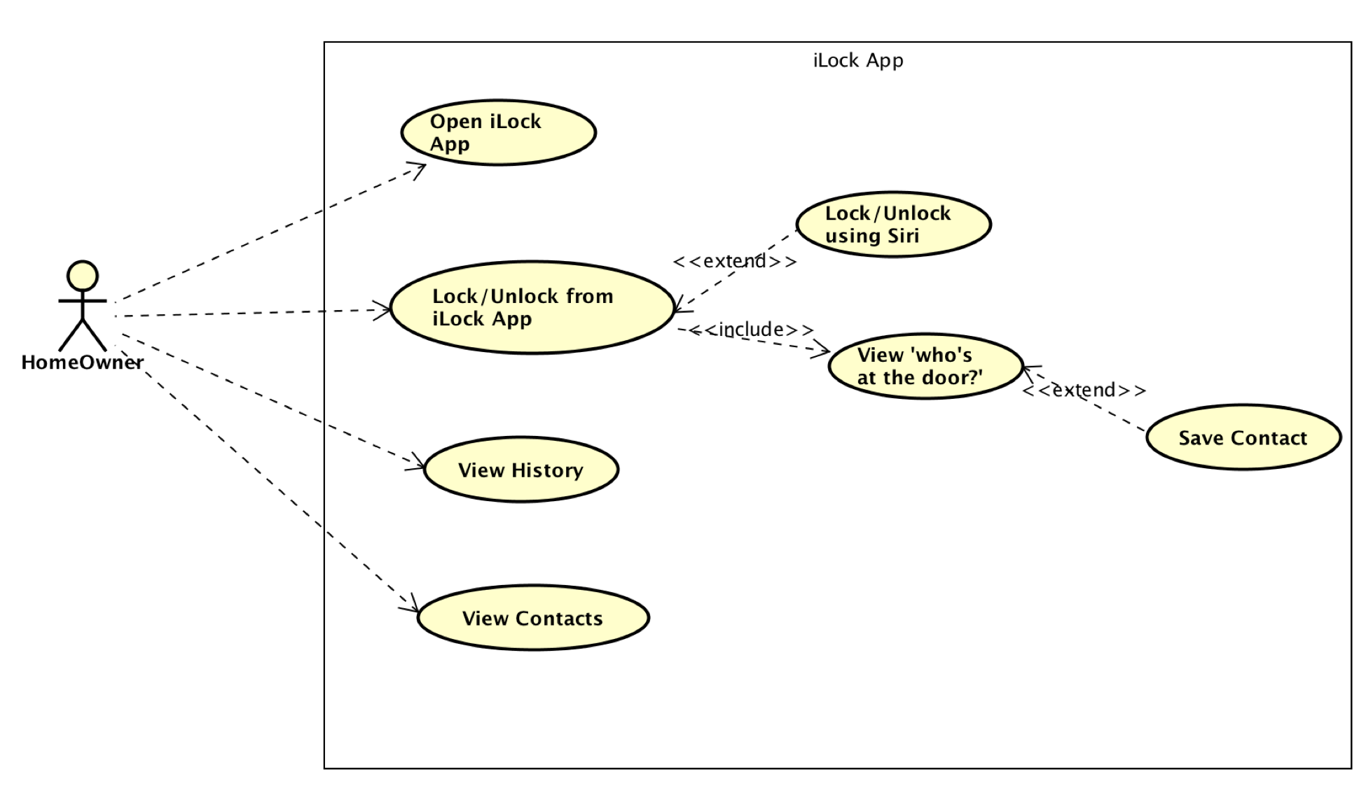Fig 27. Use-Case Diagram of Homeowner.

## **9.2 Sequence Diagram**

Sequence Diagram for iLock App is shown in the below figure. 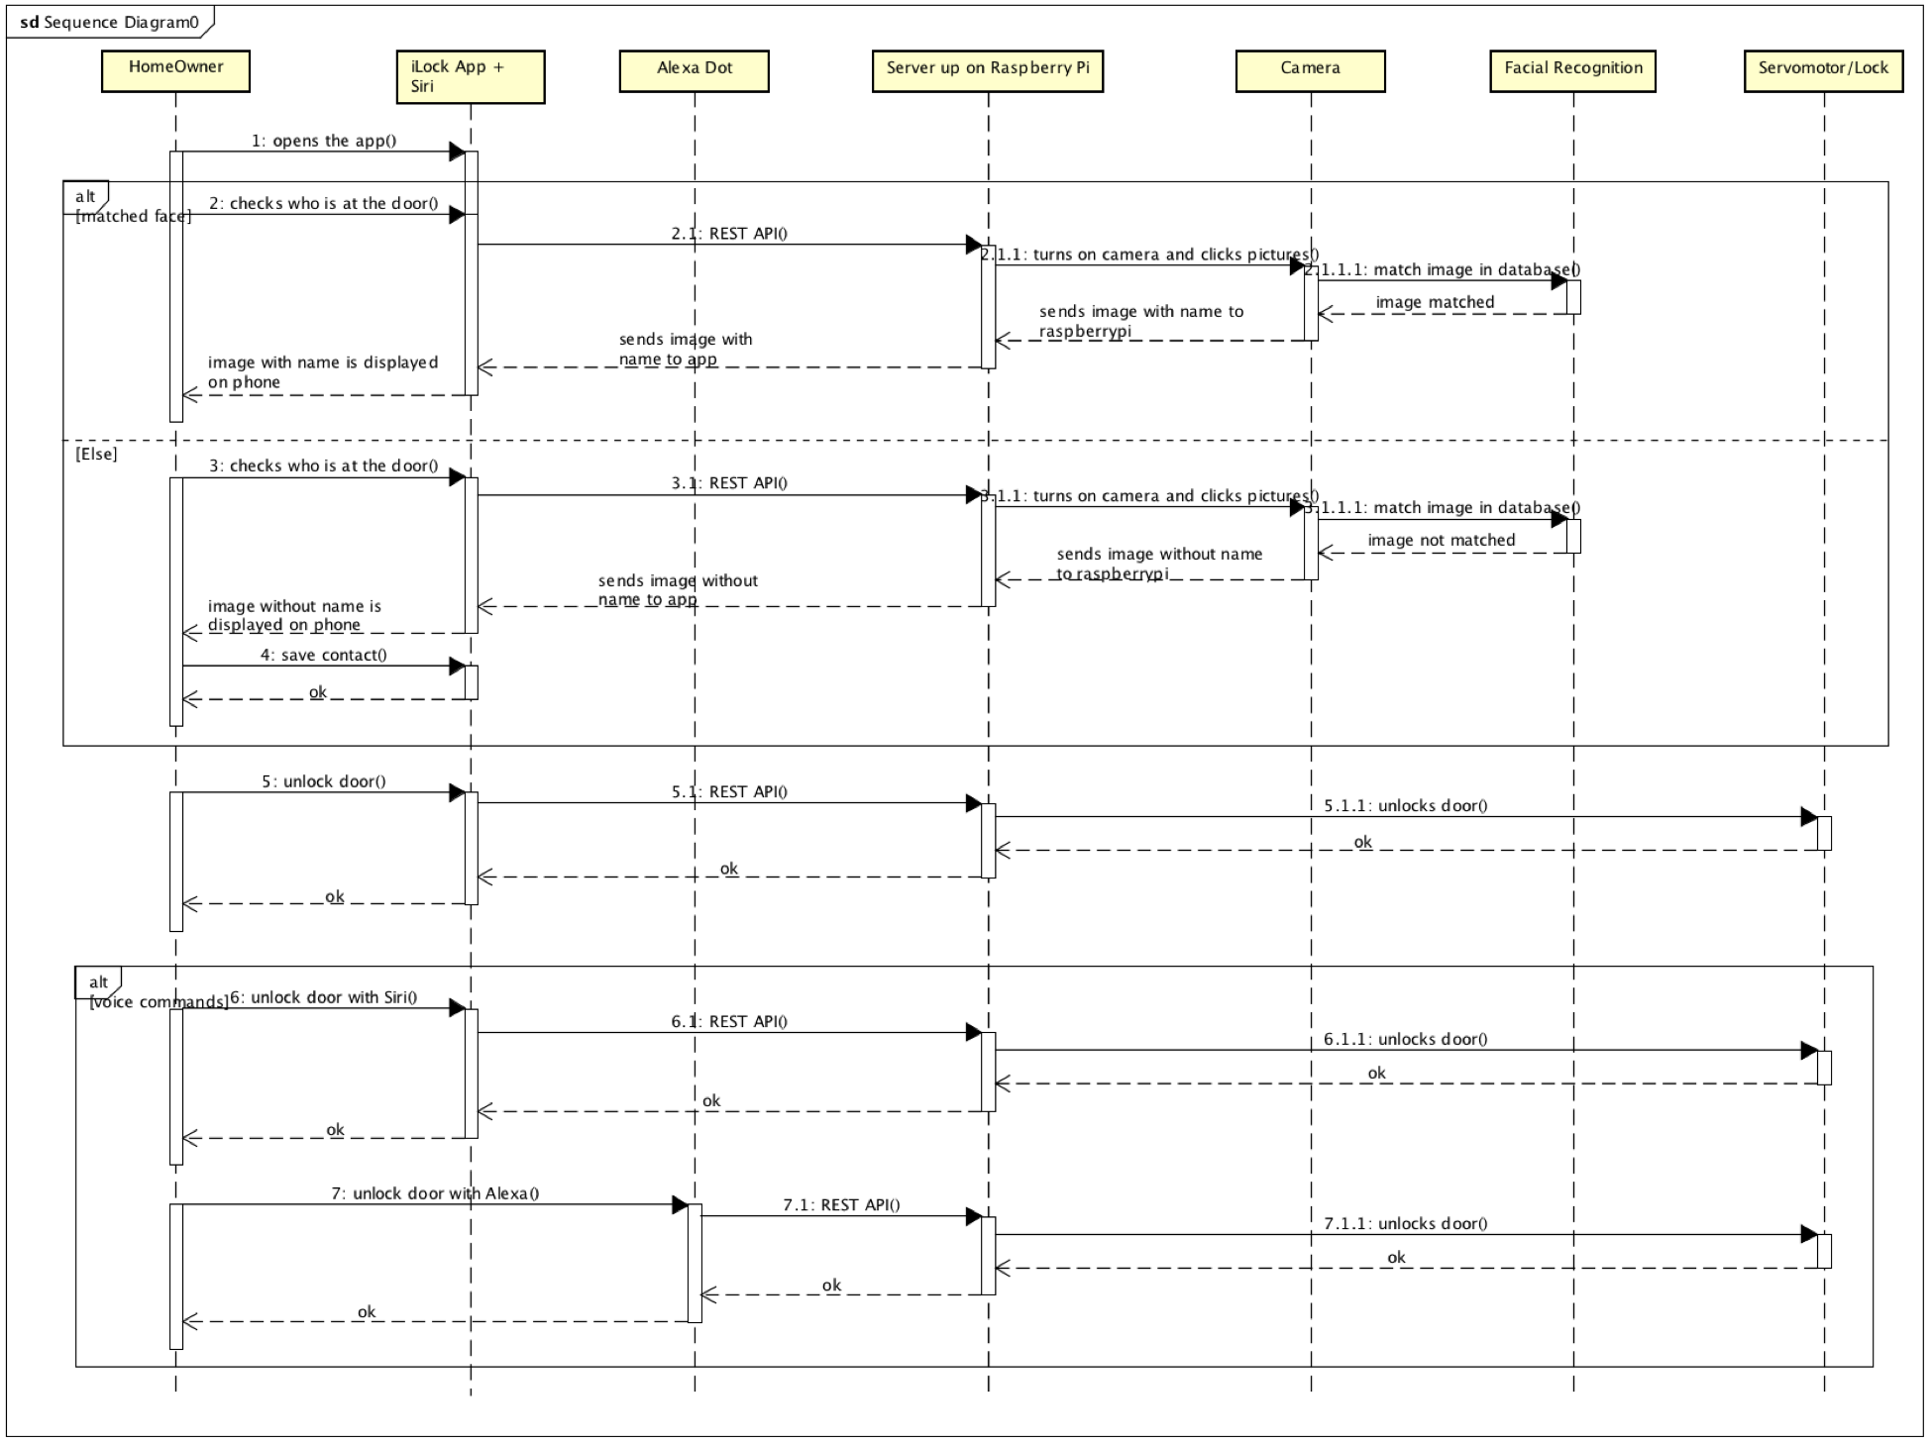

Fig 28. Sequence diagram of the iLock App.

## 

## **9.3 Storyboard**

Storyboard of iLock App is as shown below.

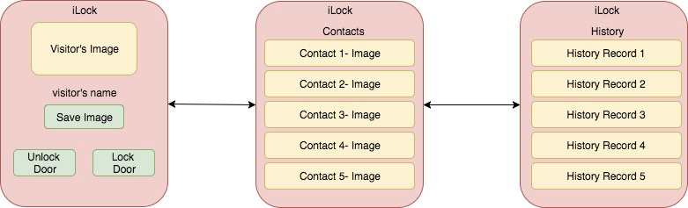

Fig 29. Storyboard of iLock App

# **10. Testing**

We have manually tested our application by using different test cases. The application passed all the test cases and performed actions as expected. We have also done the UITests on the application and the performance never deferred.

*UI Tests* - UI testing gives you the ability to interact with the UI of the application. It depends on XCTests and Accessibility. XCtest provides the framework for the testing of the user interface. XCTest is compatible with Objective-C, and Swift.

*Unit Testing:*

We have tested each functionality for a component manually, to ensure that it works fine independant of the other functionalities of the same component. This has been repeated for each unit of code for our entire project.

We have also explored XCTest Framework of XCode, which comes handy for iOS applications which you have to do in XCode. we have checked for any performance variations and user interaction flow with the XCTest for our iOS app.

*System Integration Testing:*

As a part of System Integration Testing, Any two/more components of the system are integrated and tested for any inconsistencies or any variation in the functionalities of the individual units as a part of integration. In our case, we have integrated camera module and iOS App first. Once it is passed, we have integrated camera with face detection and recognition algorithms and checked if that is working fine. After which, we have integrated camera, face detection and recognition algorithms with iOS app. There are many levels for system integration testing for this project, as we have more individual components. Once that is verified that there are no inconsistencies, we passed the project for System Integration Testing and did System Testing.

*System Testing:*

For System Testing, the entire system as whole is testing for the normal functioning. We need to make sure that the system, which includes Raspberry Pi3, Raspberry pi camera, Servo motor, Face detection and Recognition algorithms, iOS app along with Siri, Alexa Dot in our project work normally after everything is integrated in the above step. This is also done manually for our system testing and it passed all our testing phases.

We ensured that unit testing, system integration testing and system testing is passed for our project and ready to go.

# **11. Automation**

Testing of iOS applications or web- based mobile applications can be done using Selenium or WebDriver. This ios driver can be integrated with selenium grid through which we can reuse the existing infrastructure with all the classes. This testing can be done using the simulator. These tests cannot be performed on the device because Selenium Grid ios driver does not support real devices yet. It is beneficial to use web automation on simulator because it is faster than using it on real device.

# **12. Design Patterns Used**

The Design patterns which we have used for our application development are Model View Controller, Target Action Design Pattern, Delegate Pattern, Decorator Design pattern and singleton Design Pattern.

## **12.1 Model View Controller**

Model View Controller is a design pattern is the most common design pattern used in iOS application. We have also implemented the MVC model in our application. Our files are aggregated into Model, Controller and View folders.

## **12.2. Target Action Design Pattern**

Target-Action design pattern is the one in which one object sends a message to another object on the occurrence of an event. In our application we have used buttons which perform different activities on clicking them.

## **12.3 Delegate Pattern**

Delegation design pattern is a pattern where one object acts on behalf of another object. We have used delegate design patterns by implementing UITableView and TextField.

## **12.4 Adapter Design Pattern**

Adapter design pattern allows incompatible interfaces to work together. We have UITableViewdelegate for our table view container .

## **12.5 The Facade Design Pattern**

This design pattern is used for as a single interface to complex subsystem. In our app we have represented as our app structure in a tabular form.

# **13. Profiling**

## **13.1 Development Plan**

|  |  |  |  |  |
| --- | --- | --- | --- | --- |
| **#** | **Milestone** | **Assignee** | **Progress** | **Status** |
| 1 | Brainstorm on Project Ideas | All | 100% | Done |
|  | Submit Project Ideas to Professor | All | 100% | Done |
|  | Select Project Idea | All | 100% | Done |
| 2 | Research on the Topic | All | 100% | Done |
|  | Get related material | All | 100% | Done |
|  | Research on the Raspberry Pi | Sneha | 100% | Done |
|  | Integrate the Raspberry Pi with iOS App | Sneha | 100% | Done |
| 3 | Explore on Alexa Kit | Mounika | 100% | Done |
| 4 | Explore on Siri Kit | Alekhya | 100% | Done |
| 5 | Explore on ML model for face recognition | Pooja | 100% | Done |
| 6 | Explore on taking pictures using Raspberry Pi Camera | Priya | 100% | Done |
| 7 | Component Design and Development |  | 100% | Done |
|  | Design Component functions  (function partition/process/algorithm) | All | 100% | Done |
|  | Design Component API | Priya | 100% | Done |
|  | Design Component Logic  (use case and sequence diagram) | Mounika | 100% | Done |
|  | Design Component GUI  (GUI layout and operation flow) | Alekhya | 100% | Done |
|  | Develop prototype for component | Sneha | 100% | Done |
|  | Demo & gather feedbacks | All | 100% | Done |
| 7 | Final Development & Presentation |  | 100% | Done |
|  | Brainstorm for modification ideas based on feedbacks | All | 100% | Done |
|  | Upgrade application | All | 100% | Done |
|  | Testing | All | 100% | Done |
|  | Prepare for Presentation | All | 100% | Done |

### 

# **14. References**

1. <https://medium.com/@sntaus/image-classification-using-deep-learning-hello-world-tutorial-a47d02fd9db1>
2. <https://developer.amazon.com/alexa>
3. <https://cmusatyalab.github.io/openface/>
4. https://developer.apple.com
5. https://www.raspberrypi.o